Client name | Astral Limited
Project name | UDAY
Module | SD
WRICEF number | 140
Version | V.01
Date | 14.07.2026
Type of development | Enhancement
Complexity | Medium

Document revision history

Date | Version | Description | Prepared by | Approved by
14.07.2026 | V.01 | create a auto release program in batch which type of this kind of development comes under the category | Sanjay Modhvadiya

Table of content
1 Overview and Scope 3
1.1 Functional Description 3
1.2 Assumptions 3
1.3 Initiating process 3
2 Detailed Functional Requirements 3
2.1 Functional Details 3
2.2 Inputs for user exit/ screen exit/ Enhancement 5
2.4 Security and Authorization 5

1 Overview and Scope

1.1 Requirement
- Custom logic to release the sales order as per the customer group 2, if customer is Distributer give overdue days 60 and if customer is Dealer give overdue days 55.
- Orders for customers as per their status of Dealer or Distributor should be auto release in batch

1.2 Assumptions
- This development will work for Paints division which is S.org 4000
- For considering overdue we have not considered any document with credit amount and any AB documents for the customers

2. Functional Requirements

STVARV PERAMETER = SALESORGANIZATION(SELECTION OPTION)

Step – 1 Derive Customer and Sales Order Related Data Which Are Block:
Execute the sap standard report VKM4 = Submit program RVKRED01 pass the VKORG maintained in STVARV PERAMETER = SALESORGANIZATION(SELECTION OPTION) and CMGST = B fetch all KNKLI(Customers) & VBELN(Sales order)
Additionally fetch VBELN, BUKRS, NETWR+ MWSBK = Order Value (accumulate order value based on sales order), KVGR2_ANA from VBAP using above sales orders.

Step – 2 Derive Credit Exposure Data Customer Wise:
Execute Sap Report UKM_MALUS_DSP = Submit Program UKM_MALUS_DISPLAY Pass KNKLI in PARTNER and fetch Amount.
Add this amount in all the corresponding (Order Value in AMOUNT) if CREDIT_LIMIT - Order Value in AMOUNT if value is (+) go for next step if value is (–) don’t do anything.

Flow Chart: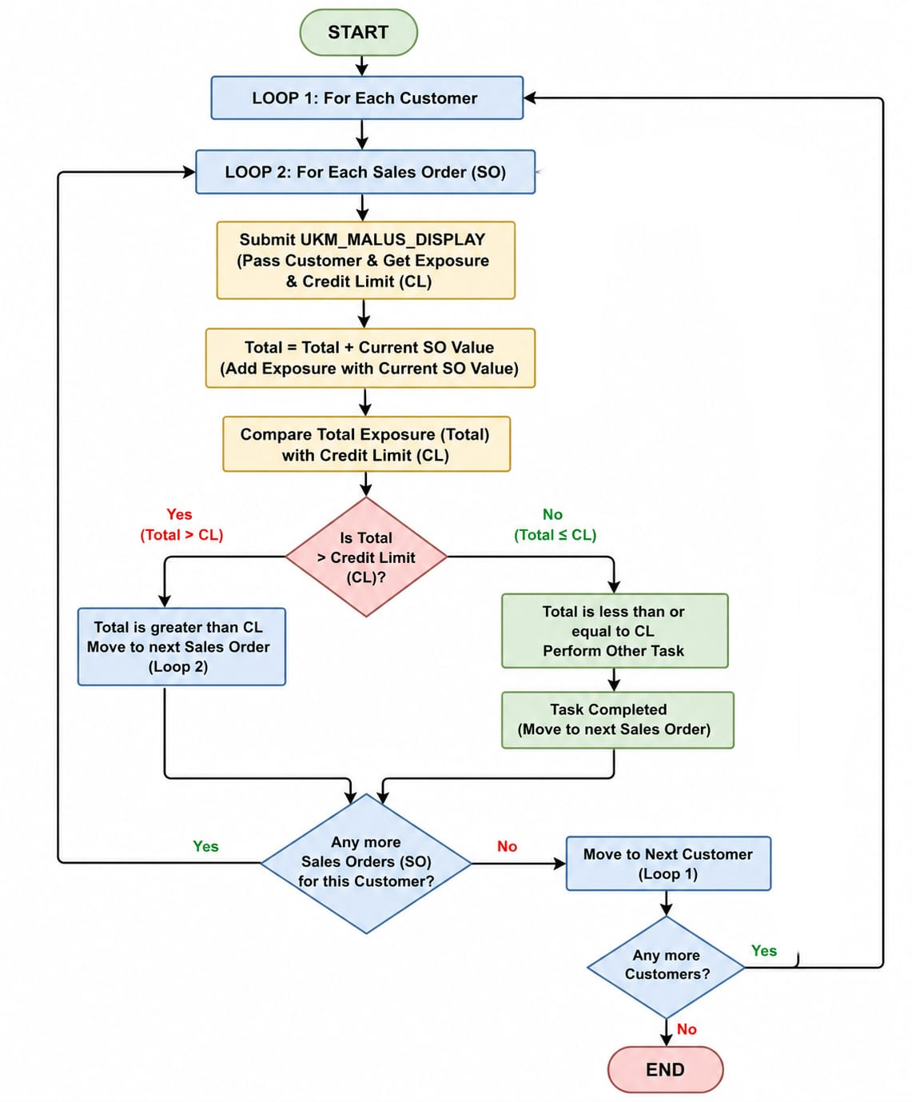

Step – 3 Derive Overdue:
Buying Group

Goto KNB1 Pass KUNNR fetch KUNNR + EKVBD = List of customers, Pass List of customers in KNB1-EKVBD fetch KUNNR+EKVBD

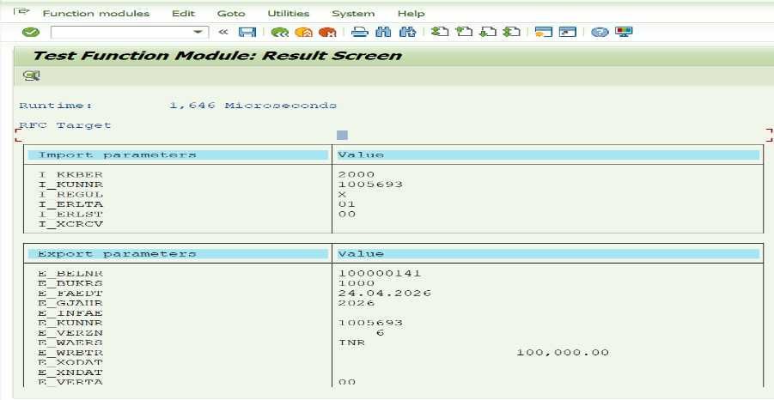
FM - CUSTOMER_OLDEST_OPEN_ITEM
Pass List of Customers in above FM if overdue comes

I_KUNNR = customer(one by one form the list of customers)
I_KKBER = 2000 (Default)
I_REGUL = X (Default)
I_ERLTA = 01 (Default)
I_ERLST = 00 (Default)

If value comes for customer, then for such customers only go-to….BSID else abort

BSID – Overdue Items
Goto BSID Pass KUNNR, BUKRS, GJAHR(always current) – From Step 1 & SHKZG ≠ H, BLART ≠ AB

Formula: SY_DATUM - (ZFBDT + ZBD1T) if ( - then it is not yet due) if (+ it is overdue)
If a customer is having overdue then then compare overdue days with KVGR2_ANA (if Distributer 60 days and if Diller 55 days)

If Overdue < KVGR2_ANA Status Release (step – 1 hold sales order)
If Overdue > KVGR2_ANA don’t do anything

Step – 4 for status Release

To release use FM - SD_ORDER_CREDIT_RELEASE
Pass Sales Order in VBELN
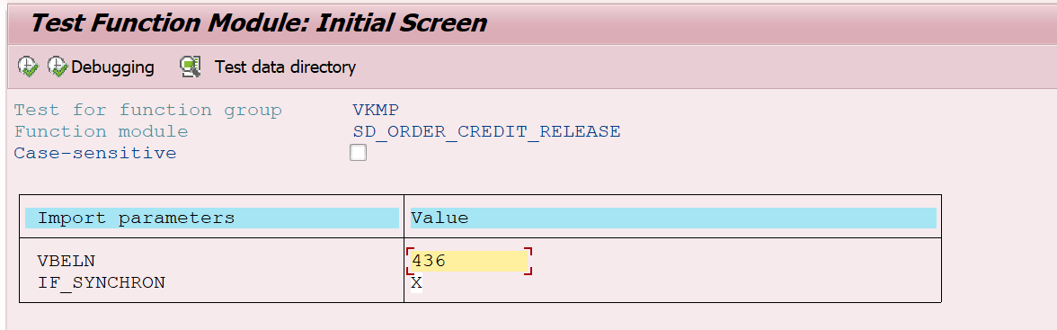

2.4 SECURITY AND AUTHORIZATION

Authorization TBD

3 TESTING REQUIREMENTS

3.1 UNIT TEST RESULTS
This section will be completed during the unit testing phase by the ABAP developer and functional consultant.

